# Project 11: ANSIBLE CONFIGURATION MANAGEMENT – AUTOMATE PROJECT 7 TO 10

1. Change Jenkins server name to Jenkins-ansible.

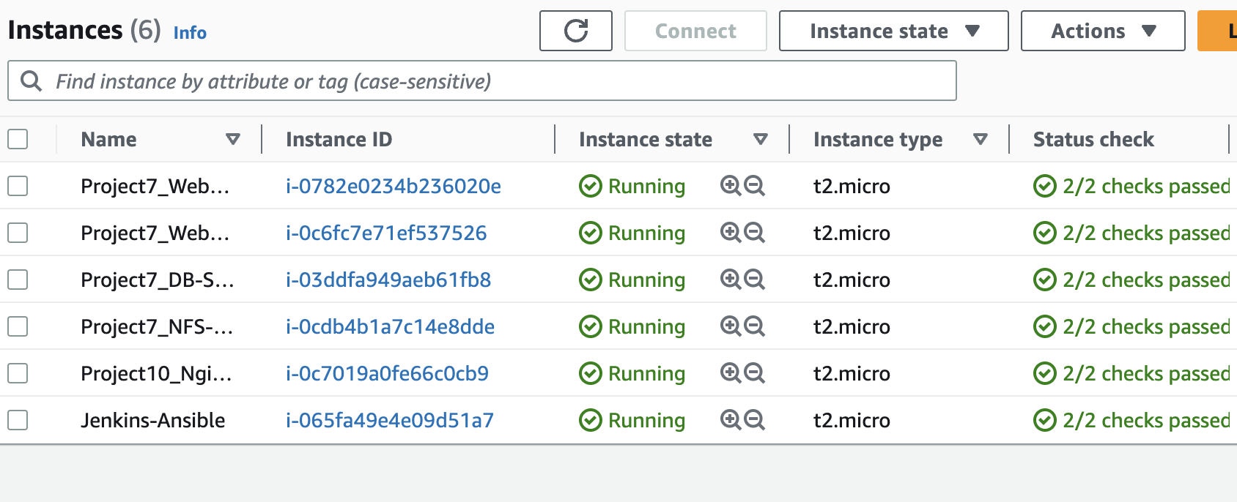

1. Get an Elastic Ip Address and attach it to the Jenkins Server

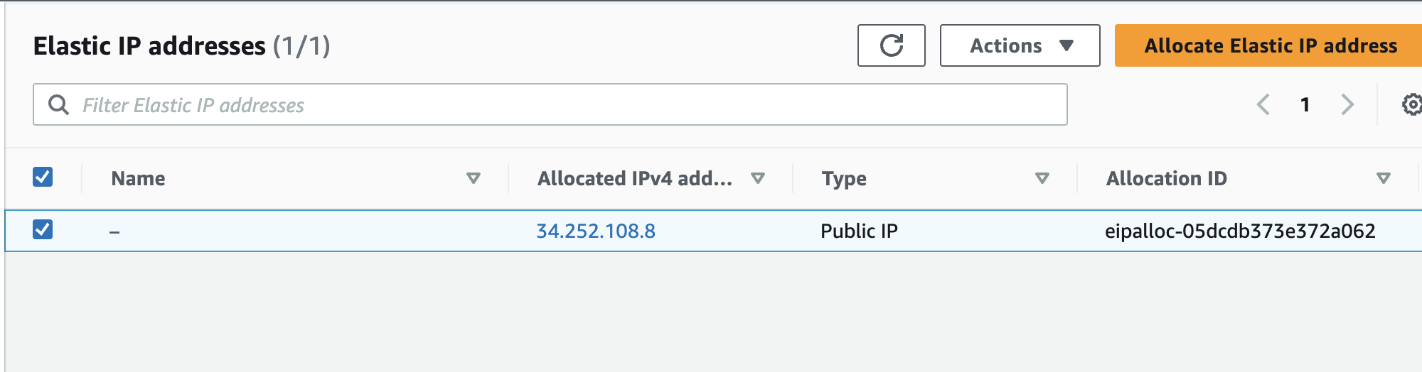

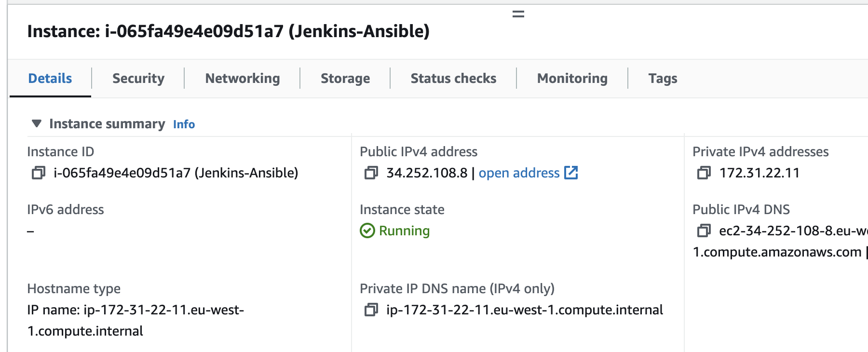

1. Create a new Repository in Github and name it ansible-config.

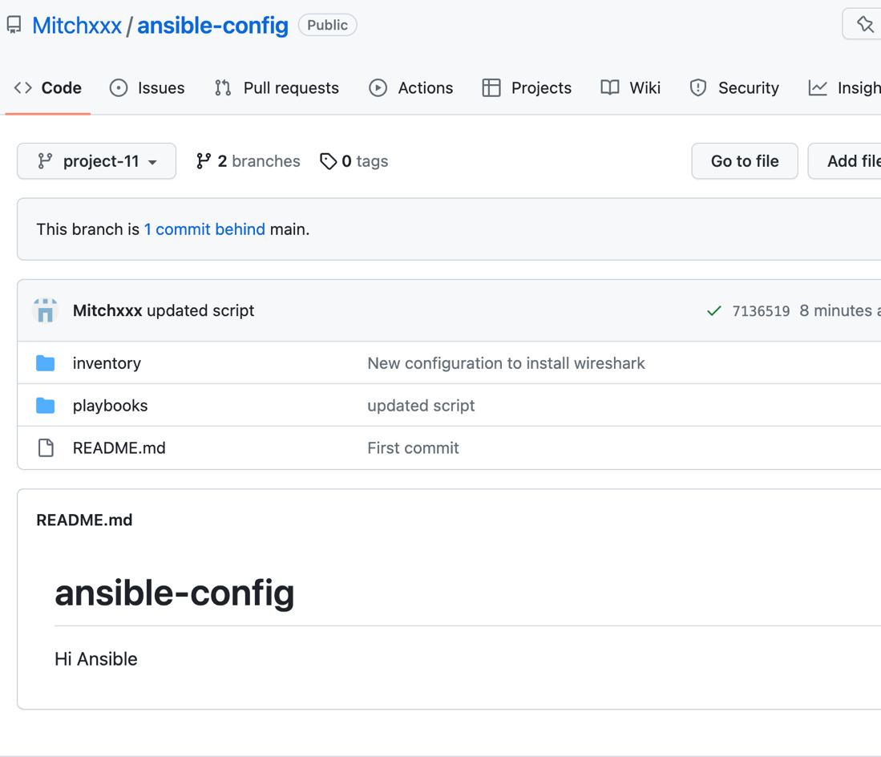

1. Set up a new webhook for the repo, create a new Jenkins freestyle job and configure the job to save all builds artifacts with the webhook.

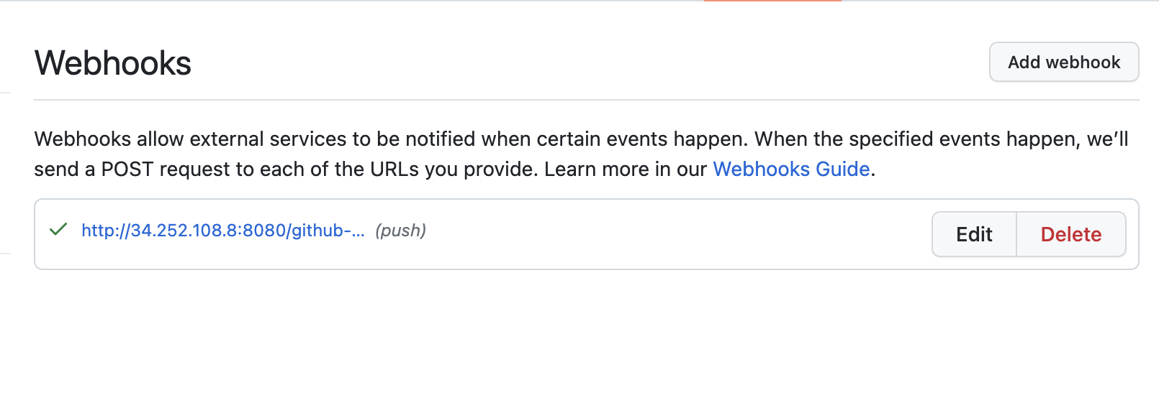

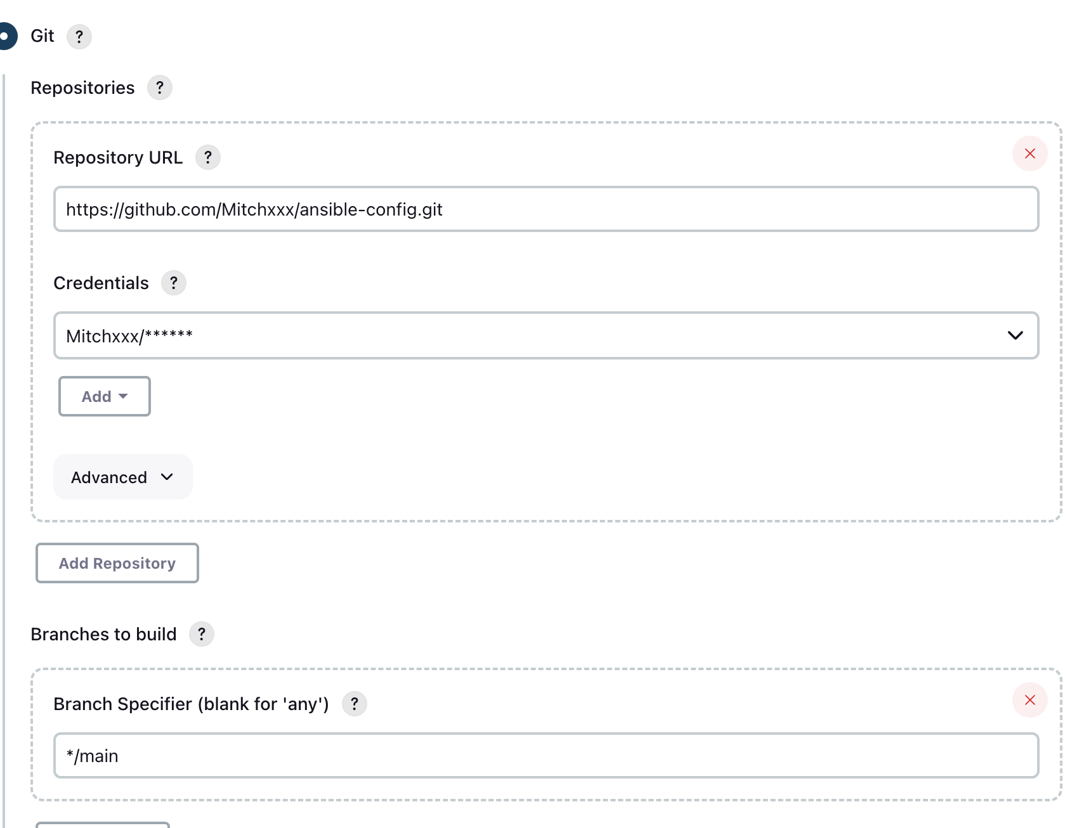

1. Install Ansible into Jenkins-server.
2. Clone the main branch of the ansible-config repo into your laptop, open it with Visual studio code, and create a new branch e.g project-11.
3. Create a directory called playbooks and create a new file name common.yml.
4. Create a directory called inventory and create 4 new files dev.yml, production.yml, uat.yml and staging.yml.
5. Add the private Ip address of the webservers, loadbalancer, database and NFS servers as hosts to the dev.yml file in the Inventory directory.

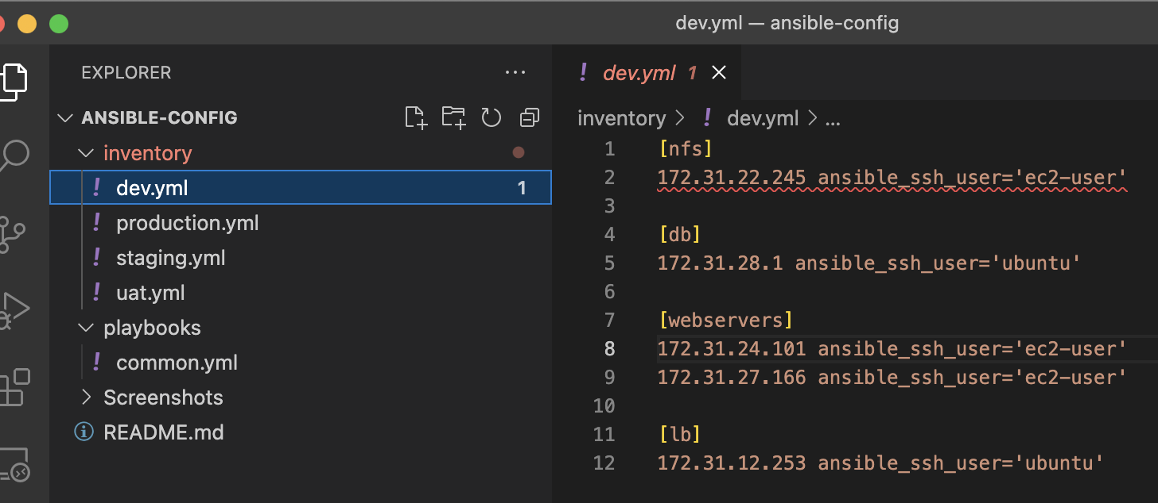

1. Write an ansible script to update and install the latest version of wireshark to the servers.

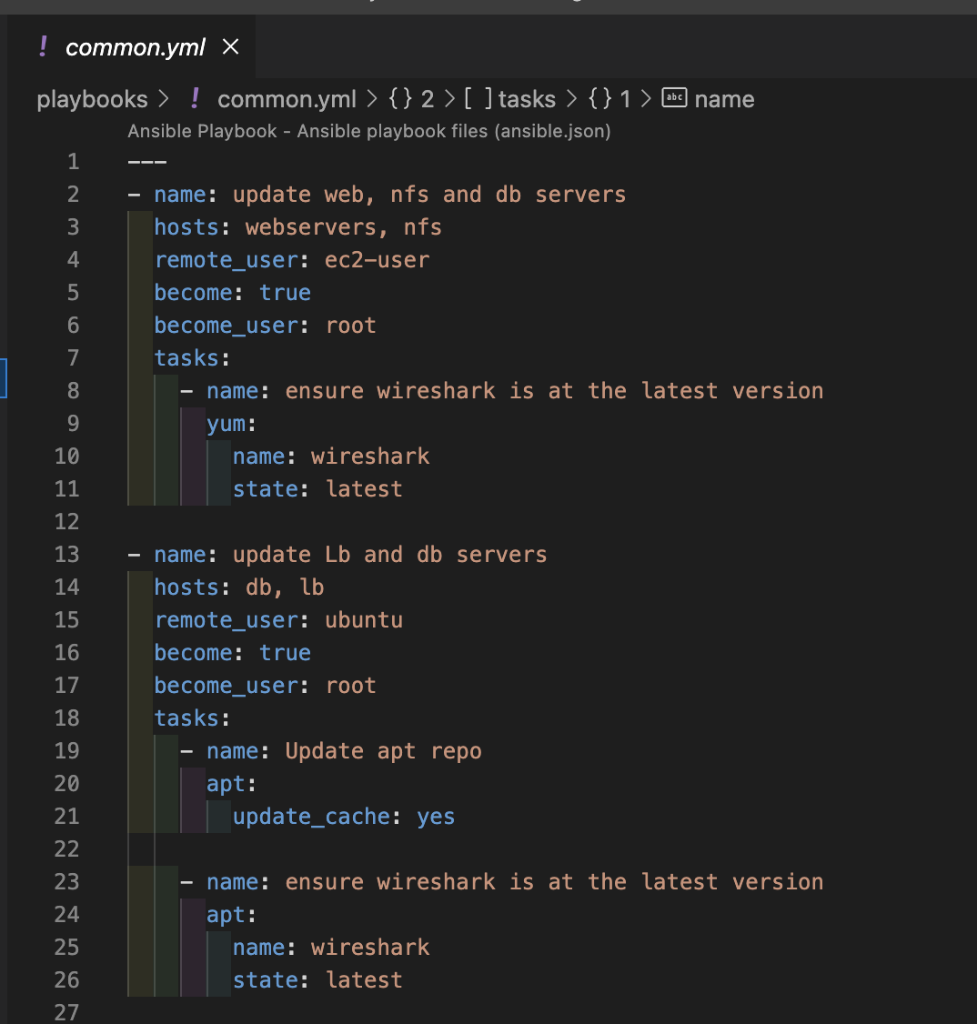

1. Commit the following files, push them to the repo and create a new pull request to merge to the main branch.
2. Review the pull request and merge the changes to the main branch.
3. Verify the build is successful in Jenkins.
4. Create a ssh agent with the following commands .

eval `ssh-agent -s`

ssh-add <path-to-private-key>

1. Confirm your ssh key as been added with “ssh-add -l”.
2. Verify you can ssh into your Jenkins-ansible server with your ssh agent.
3. Verify you the ssh agent is included in the server with “ssh-add -l”.
4. Verify you can ssh to the other servers from the Jenkins-ansible server.
5. Connect your Vscode to your Jenkins-ansible server with ssh hosts.

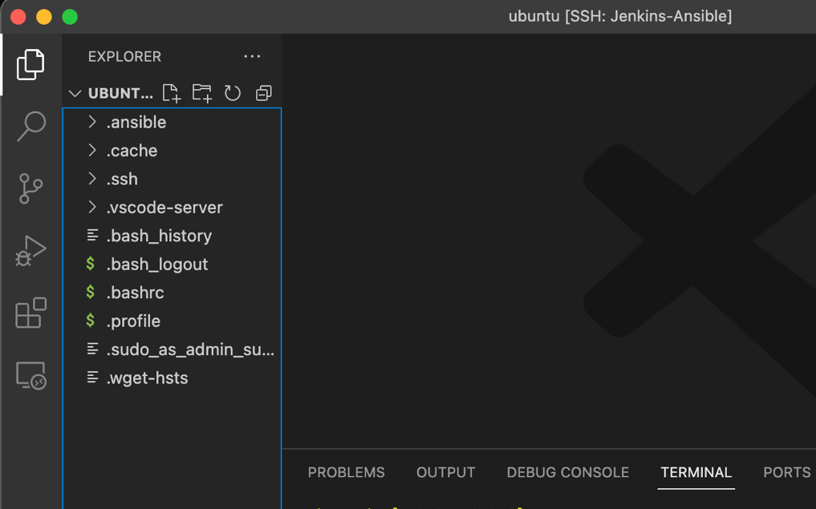

1. Navigate to the archive of the build in Jenkins with this command “/var/lib/jenkins/jobs/ansible/builds/<build number>/archive”.
2. Execute the common.yml playbook with the following command “ansible-playbook -I <inventory location> <playbooklocation> .

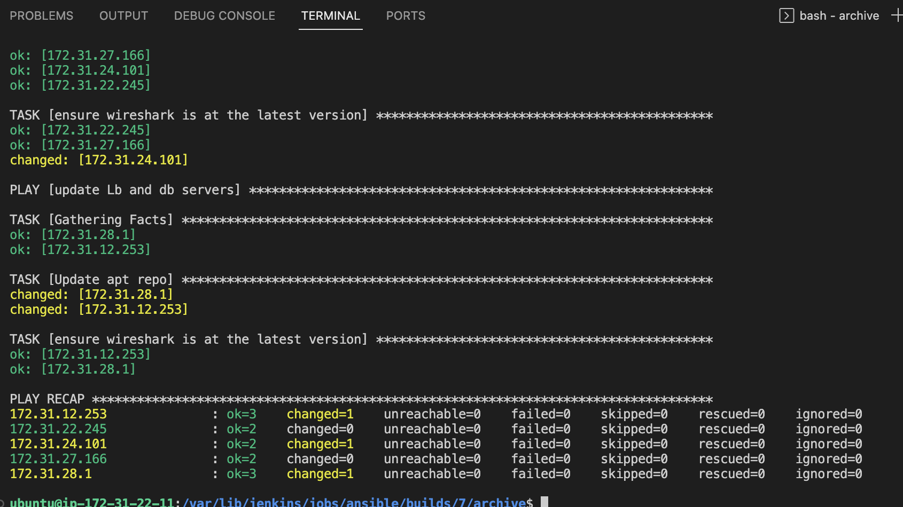

1. Verify Wireshat Is installed in the servers.

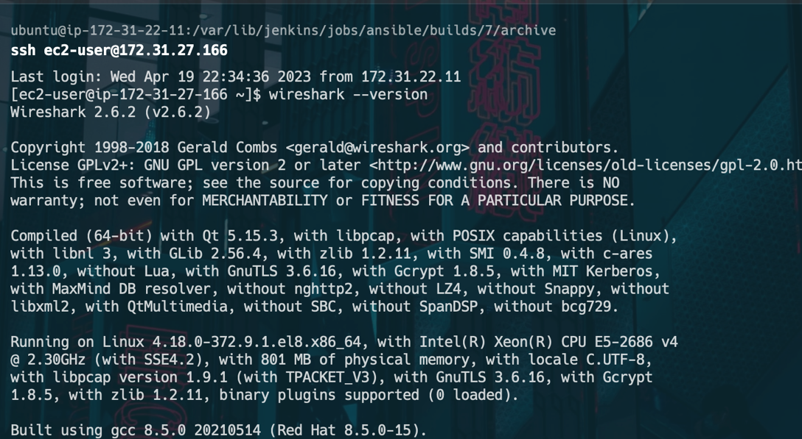

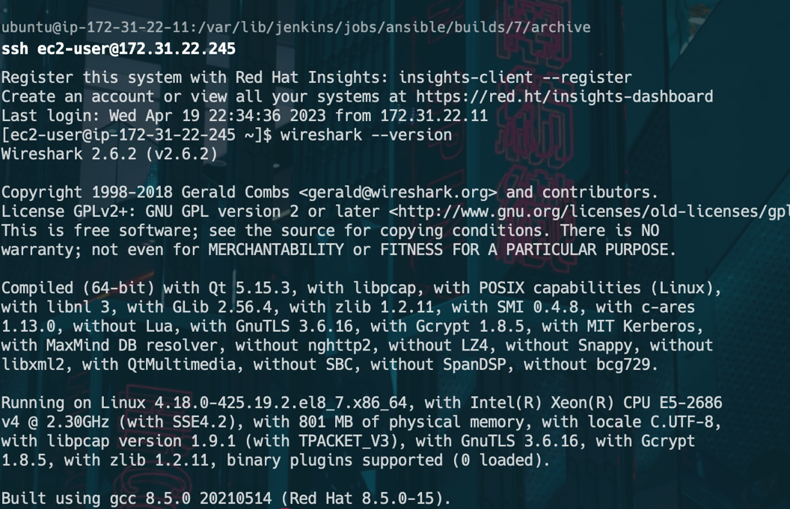

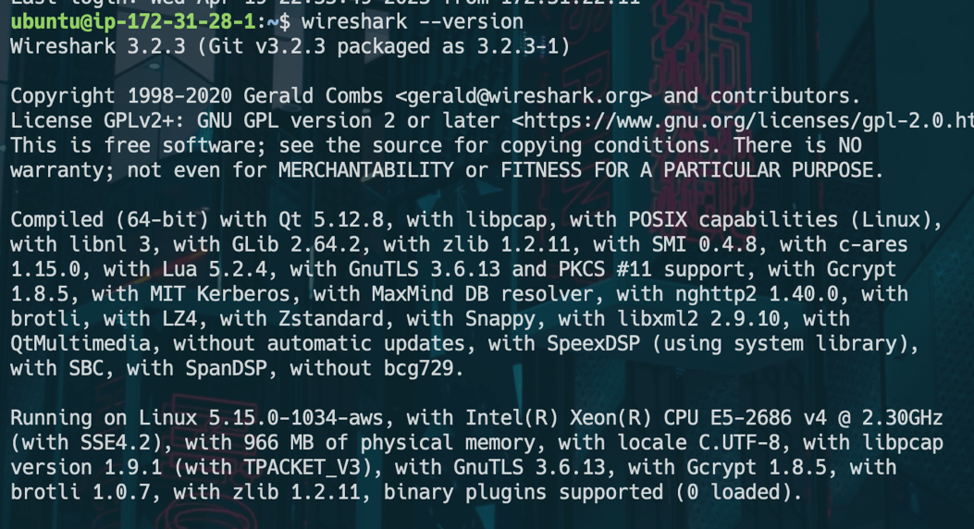

1. Add a new task to the coomon.yml playbook to create a new folder, file and update the timezone.

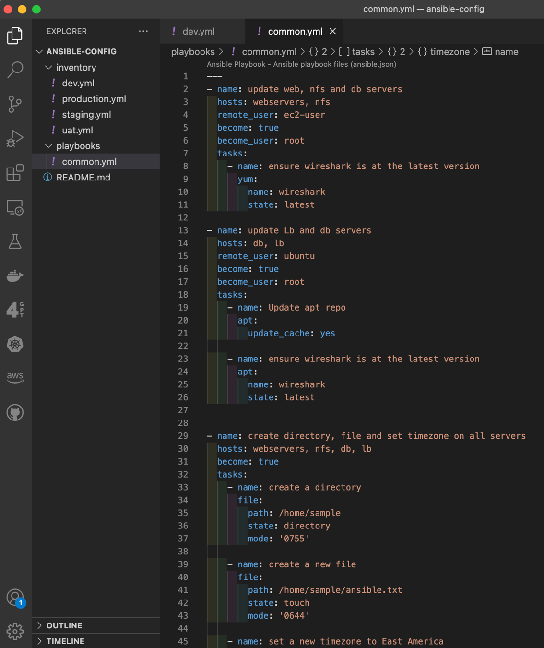

1. Commit , push, merge, pull and build the code.
2. Execute the common.yml playbook from the new Jenkins build.

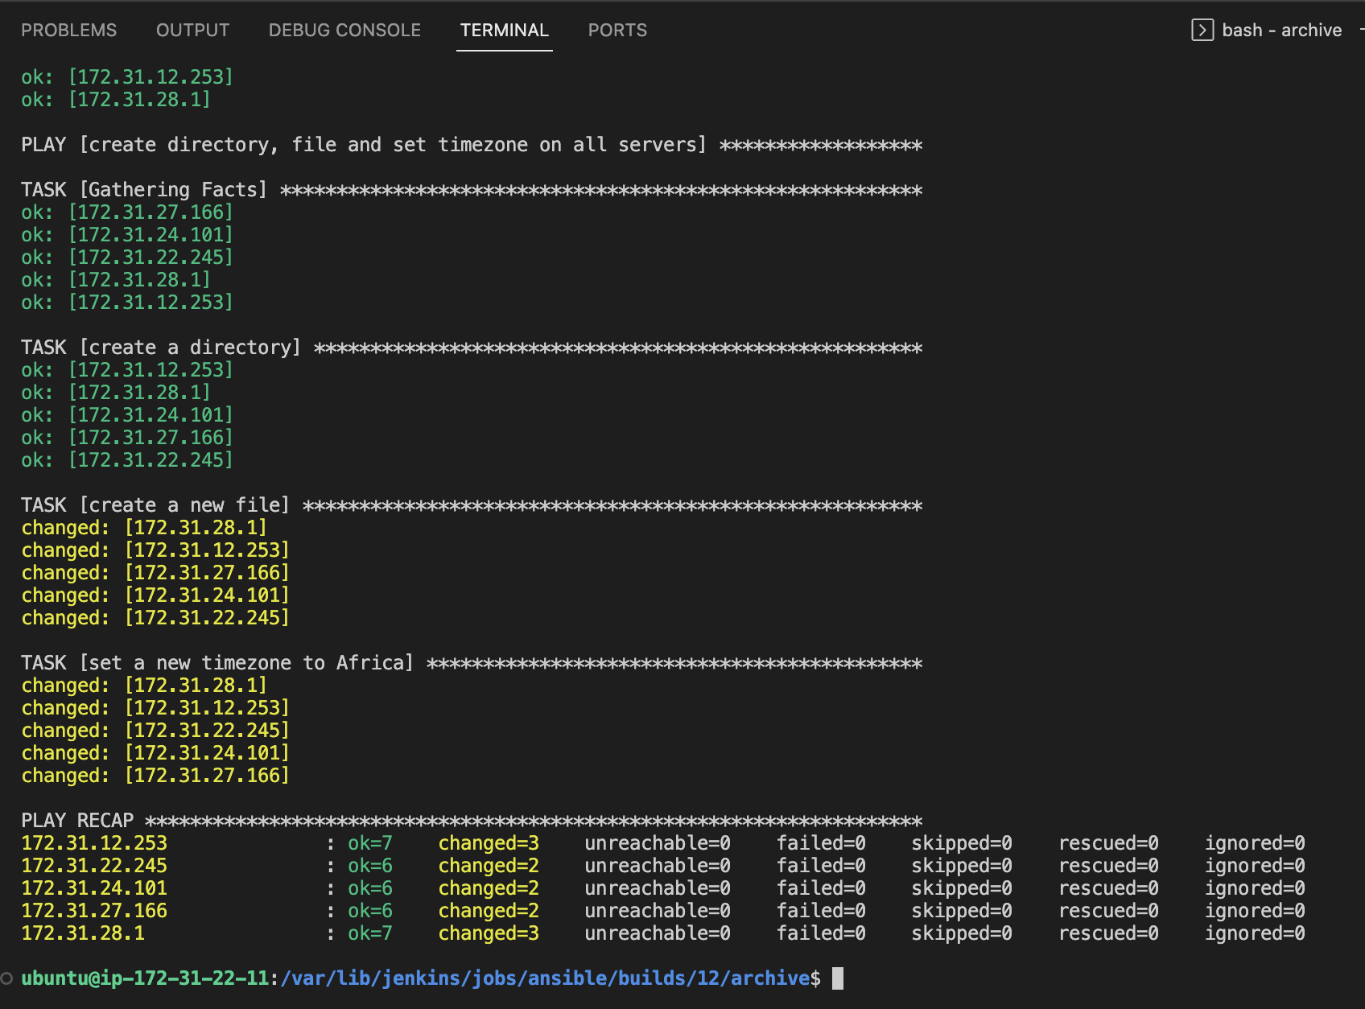

1. Verify the folder, file and timezone from the servers.

